###### 

**PUCIT**

Punjab University College of Information Technology

**Second Deliverable for Object Oriented Approach**

**Version 1.0**

**TABLE OF CONTENTS**

1 Introduction 3

1.1 Use Case descriptions 3

1.2 Use Case Diagram (Refined) 4

1.3 Domain Model 4

1.4 Sequence Diagram 6

*1.4.1. Defining a Sequence diagram 6*

*1.4.2. Basic Sequence Diagram Symbols and Notations 6*

*1.4.3 Example 10*

*1.4.4 Distributing Control Flow in Sequence Diagrams 10*

1.5 Collaboration Diagram 13

*1.5.1 Contents of Collaboration Diagrams 14*

*1.5.2 Constructs of Collaboration Diagram: 14*

1.6 Operation Contracts 15

1.7 Design Class Diagram 16

*1.7.1 Create Initial Design Classes 16*

*1.7.2 Designing Boundary Classes 17*

*1.7.3 Designing Entity Classes 17*

*1.7.4 Designing Control Classes 17*

*1.7.5 Identify Persistent Classes 18*

*1.7.6 Define Class Visibility 19*

*1.7.11 Design Class Relationships 23*

1.8 Data Model 27

# 

## ***1 Introduction***

Third deliverable is all about the use case modeling and software design. In the previous deliverable, analysis of the system is completed. So we understand the current situation of the problem domain. Now we are ready to strive for a solution for the problem domain by using an object-oriented approach. Following artifacts must be included in this deliverable.

1. Use case description
2. Use case diagram refined
3. Domain Model
4. Sequence Diagram
5. Collaboration Diagram
6. Operation Contracts
7. Design Class Diagram
8. Data Model

Now we discuss these artifacts one by one as follows:

## ***1.1 Usecase Description***

**Use Case Descriptions**

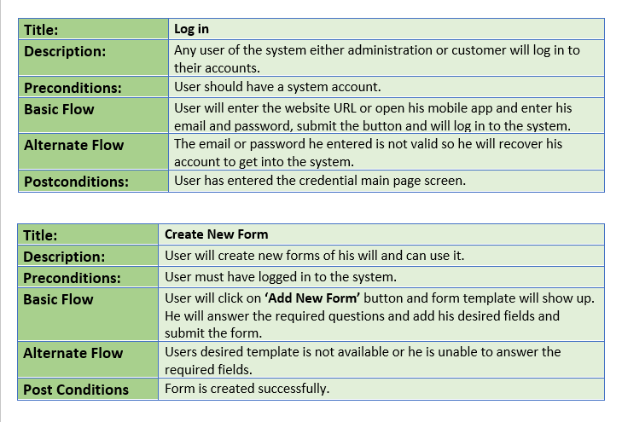

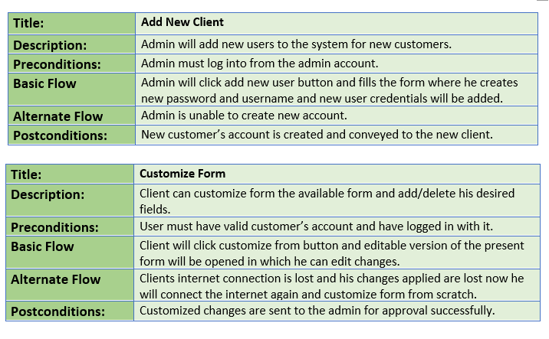

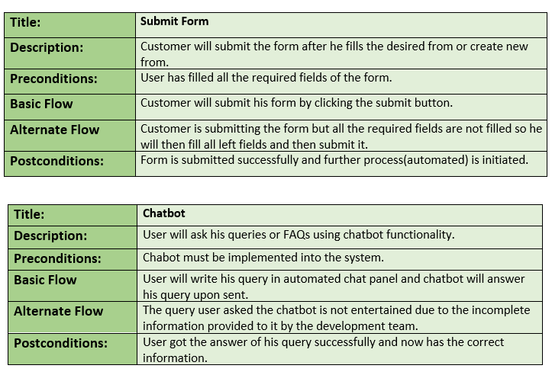

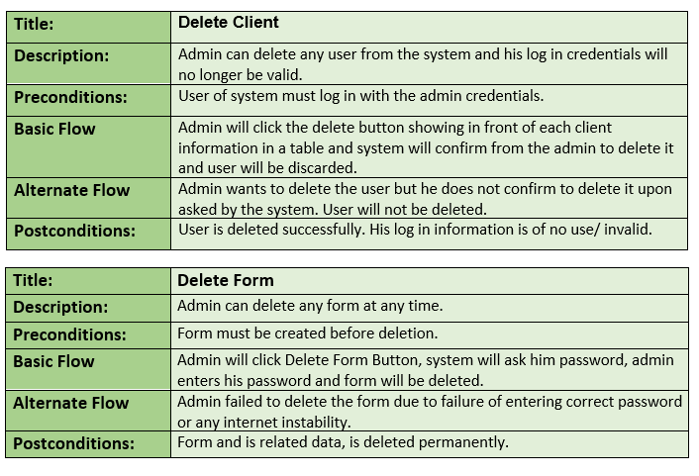

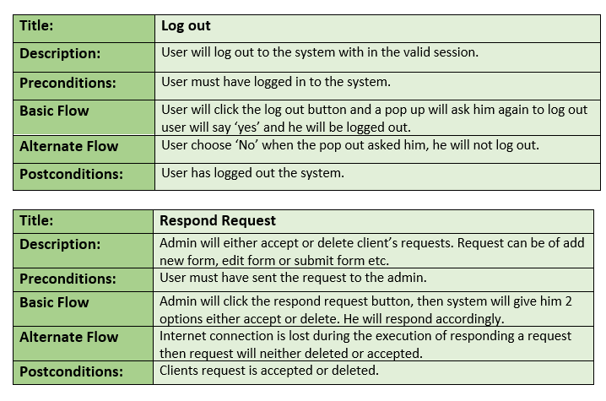

## ***1.2 Usecase Diagram (refined and updated)***

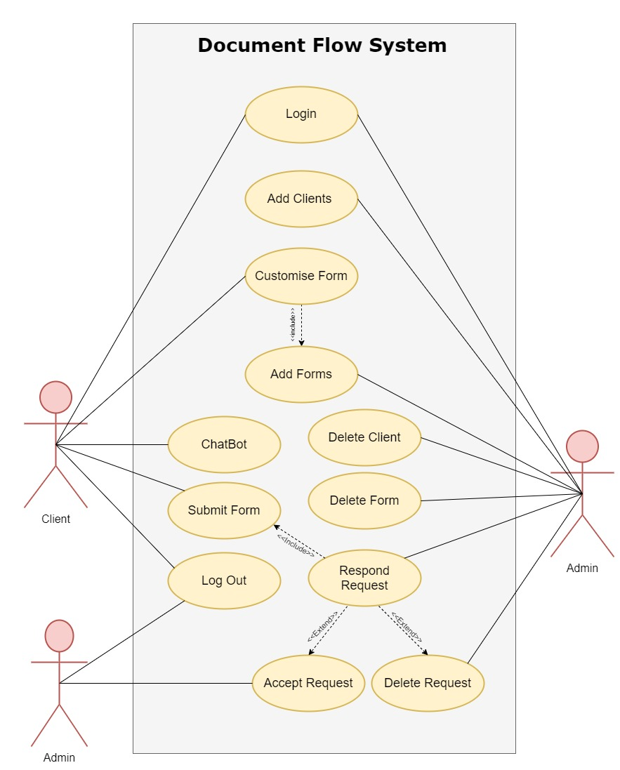

## ***1.3 Domain Model***

## 

## ***1.4 Sequence Diagram***

**Login:**

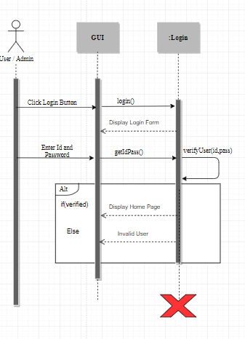

**Add Client:**

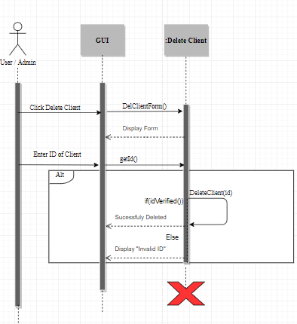

**Add Form:**

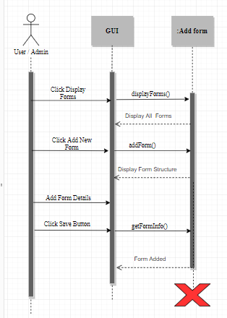

**Submit Form:**

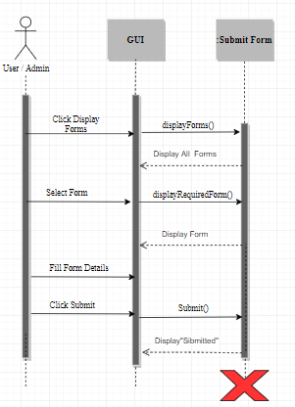

**Delete Form:**

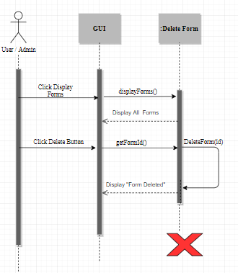

**Respond Request:**

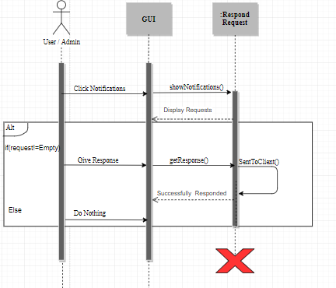

**Chatbot:**

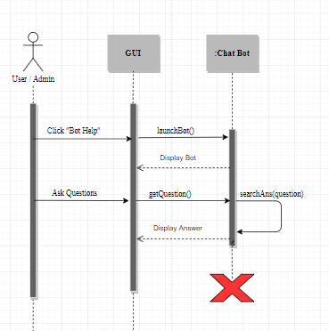

## ***1.5 Collaboration Diagram***

**Login:**

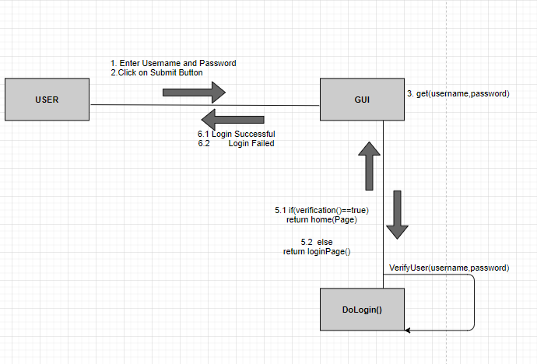

## Add client:

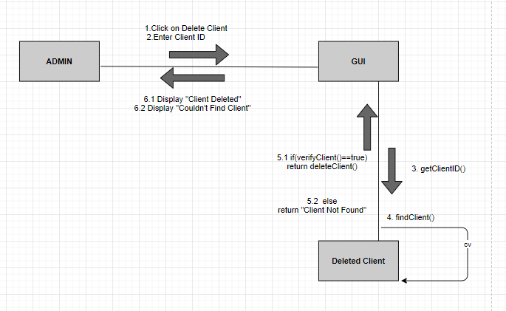

**Add Form:**

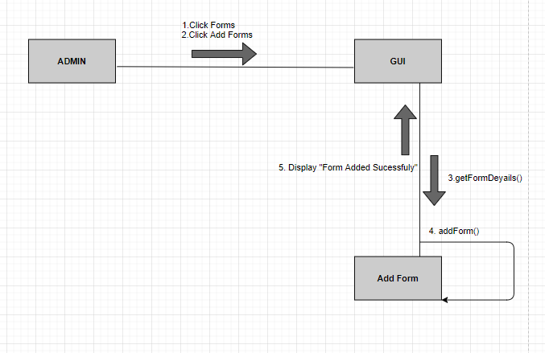

**Submit Form:**

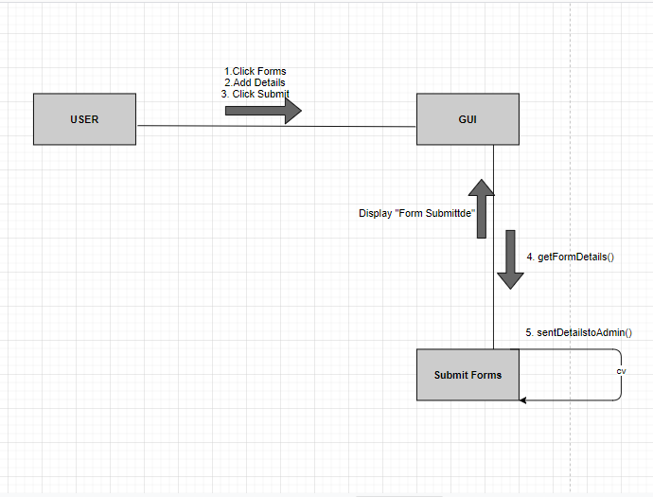

**Delete Form:**

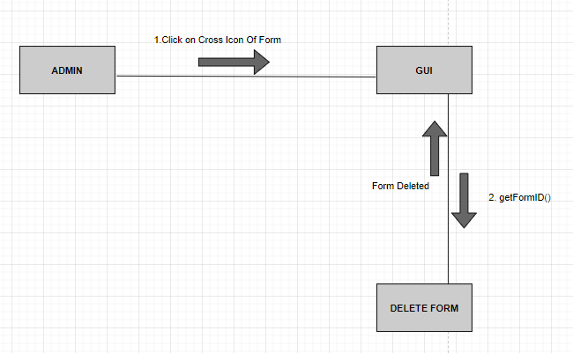

**Respond Request:**

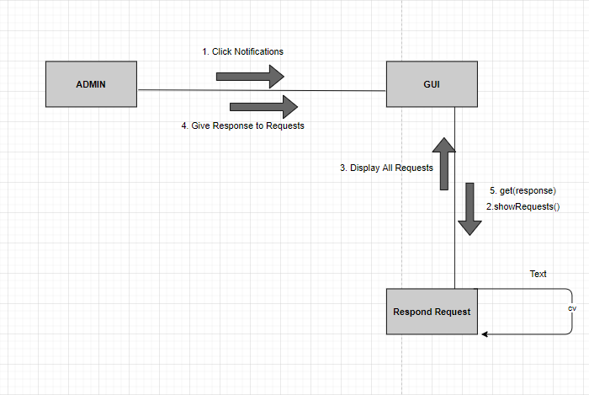

**Chat Bot:**

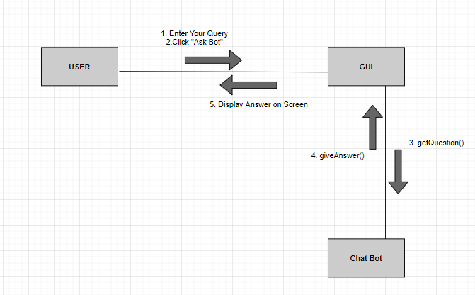

## ***1.6 Operation Contracts***

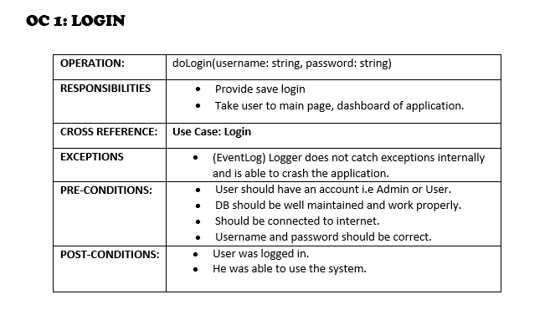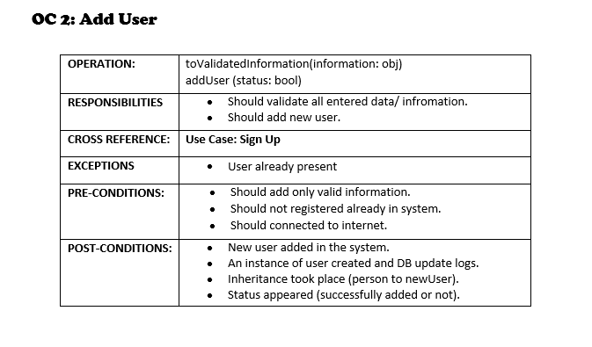

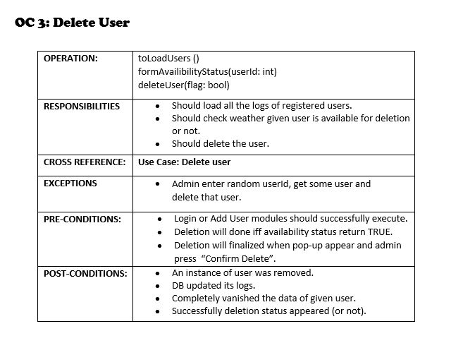

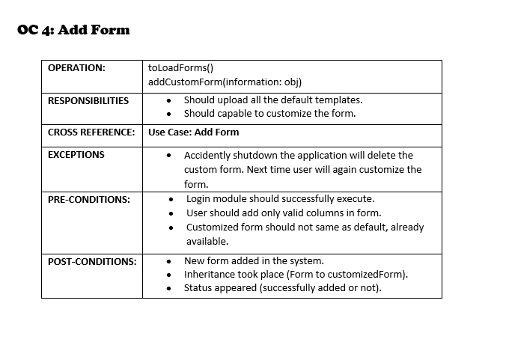

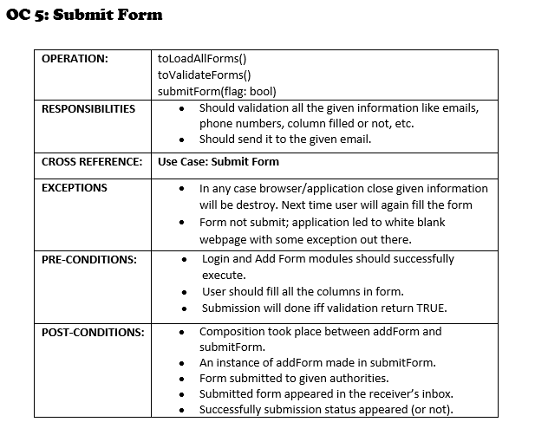

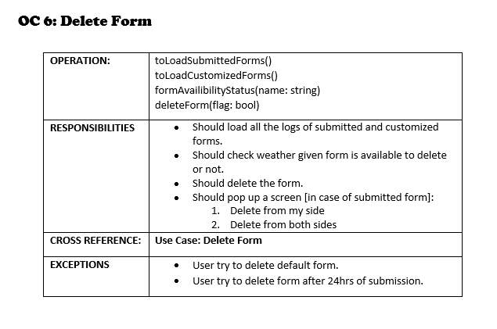

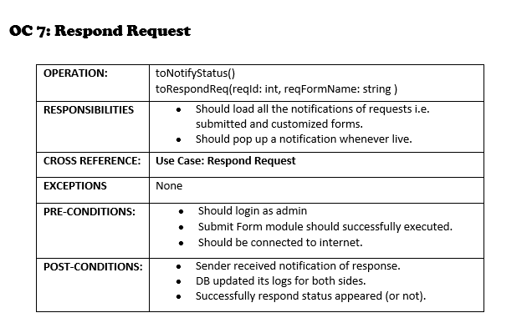

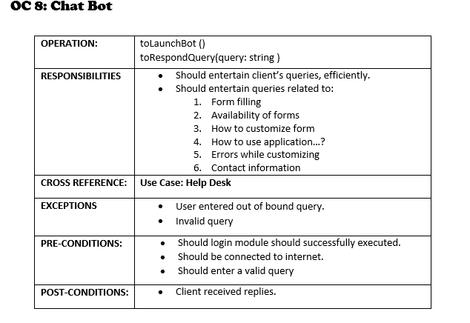

## ***1.7 Design Class Diagram***

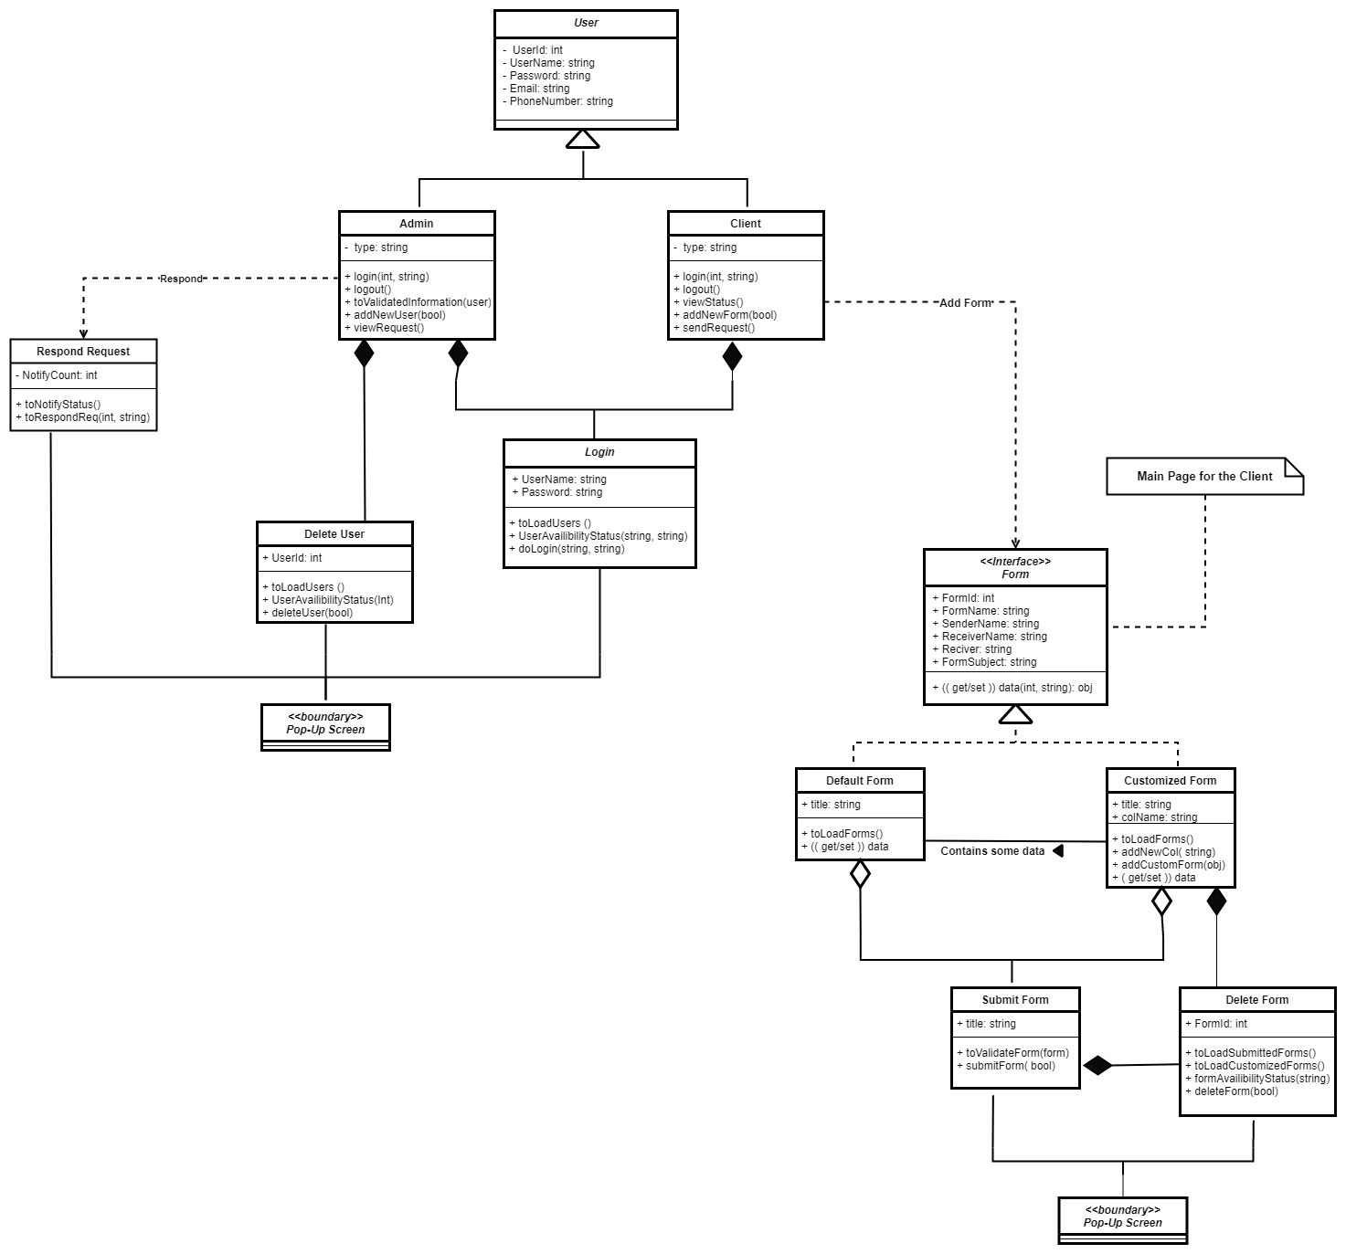

## ***1.8 Data Model***

The data model is a subset of the implementation model, which describes the logical and physical representation of persistent data in the system.

**The Relational Data Model**

